**CASE STUDY ON**

**ENGINEERING WORKS INDUSTRIES**

**(Tamil Nadu)**

**NAME OF THE STUDENT : S.NACHAMMAI**

**ROLL NUMBER : 22IT34**

**REGISTER NUMBER : 711722205034**

**SUBJECT CODE /NAME : GE3451 / Environmental Science and Sustainability**

**DATE OF SUBMISSION : 11.05.2024**

**ENGINEERING WORKS INDUSTRIES IN NSN PALAYAM, TN**

**Objective:**

The business strategy aimed at positioning the company as a trusted provider of mold preparation services while driving sustainable growth and value creation.

Top of Form

**Observation:**

I have visited NSR Engineering Works company. Overall Occupational health and Safety management Practice in NSR Engineering Works was found to be really good.

**Production process:**

Creating molds using sea sand and two types of fuel involves a process known as sand casting, which is a common method for producing metal castings. Here's a basic outline of the process:

**Sand Preparation**: Sea sand can be used as the primary material for making molds. However, it needs to be cleaned and processed before use to remove impurities such as salt and organic matter. The sand is typically washed, dried, and sieved to achieve the desired particle size distribution.

**Binder Addition**: In sand casting, a binder is mixed with the sand to hold it together and give it the necessary strength to retain the shape of the mold. There are various types of binders available, including clay, resin, and water-based binders. For this process, let's consider using two types of fuel as binders: coal and coke.

**Mold Preparation**: The sand mixed with the binder is packed around a pattern, which is a replica of the desired casting. The pattern is typically made of wood, metal, or plastic. The mold is formed by packing the sand mixture around the pattern in a molding flask, creating a cavity that matches the shape of the desired part.

**Casting**: Once the mold is prepared, it is ready for casting. The mold is placed in a casting pit or on a casting floor, and molten metal is poured into the cavity. The metal fills the void left by the pattern and takes its shape as it solidifies.

**Cooling and Removal**: After the metal has solidified, the casting is allowed to cool and harden. Once cooled, the mold is broken away from the casting, revealing the final part. The casting may undergo additional finishing processes such as machining, grinding, or surface treatment as needed.

**Reuse or Recycling**: The sand from the mold can be reclaimed and reused in future casting operations. Any leftover metal scraps can be recycled.

**Generation Of Waste:**

**Unused or Excess Fuel**: Depending on the efficiency of the conversion process, there may be unused or excess fuel. This could be due to overestimation of fuel requirements or inefficiencies in the conversion process.

**Residue from Soil Conversion**: The process of converting sea soil into mold using fuels may generate residue or by-products. This could include ash, unburnt carbon, or other non-converted materials.

**Packaging Waste**: If the fuels or other materials used in the process come packaged, there may be waste generated from packaging materials such as plastic, cardboard, or metal.

**Air Emissions**: Depending on the type of fuels used and the combustion process, there may be emissions of gases such as carbon dioxide, sulfur dioxide, nitrogen oxides, and particulate matter. Proper emission control measures should be in place to minimize environmental impact.

**Wastewater**: Depending on the process and any cleaning or washing steps involved, wastewater may be generated, containing contaminants from the soil or fuel residues. Proper treatment and disposal of this wastewater are essential to prevent environmental pollution.

**Maintenance Waste**: Machinery used in the conversion process may require maintenance, leading to waste such as used lubricants, filters, or worn-out parts.

**7.Contaminated materials**: If the sea soil contains pollutants or contaminants, there might be waste generated in the form of contaminated soil or by-products from the purification process.

**8.Ash and residue**: Combustion of fuels can result in the generation of ash and other residues, especially if the fuels contain impurities or additives. Proper disposal or treatment of these residues may be necessary to prevent environmental contamination.

**9.Emissions**: The combustion of fuels can also produce emissions such as greenhouse gases, particulate matter, and other air pollutants. Regulatory compliance and emissions control measures may be required to minimize environmental impact.

**10.Energy consumption**: The energy-intensive nature of converting sea soil into mold using fuels can result in significant energy consumption and associated waste in the form of energy losses

**Disposal Method:**

**Recycling and Reuse**: Where possible, materials such as packaging waste or certain residues could be recycled or reused within the company's operations or sold to other industries for reuse.

**Landfill Disposal**: Non-recyclable and non-hazardous waste may need to be disposed of in landfills. However, this should be the last resort, and efforts should be made to minimize the volume of waste sent to landfills.

**Incineration**: Some waste materials, such as certain residues or contaminated materials, may be suitable for incineration. Incineration can reduce the volume of waste and can sometimes generate energy in the form of heat or electricity if properly managed.

**Hazardous Waste Disposal**: If any waste generated is classified as hazardous, it must be disposed of following specific regulations for hazardous waste management. This often involves specialized treatment and disposal methods to ensure the safety of human health and the environment.

**Composting**: If organic materials are present in the waste stream, such as plant-based residues, they could be composted under controlled conditions to produce nutrient-rich soil amendments.

**Wastewater Treatment**: Wastewater generated during the process should undergo appropriate treatment to remove contaminants before discharge into the environment or municipal treatment systems.

**Emission Control**: Measures should be in place to control air emissions from combustion processes, such as using filters or scrubbers to remove particulate matter and other pollutants.

**Source Reduction**: Implementing practices to minimize waste generation at the source can significantly reduce the need for disposal methods.

**Conclusion:**

Overall Occupational health and Safety Management Practice in NSR Engineering Works was monitored and Analysed. Suggestions were given to retreive the defeciency observed.

**Geo tagged photo with captions**

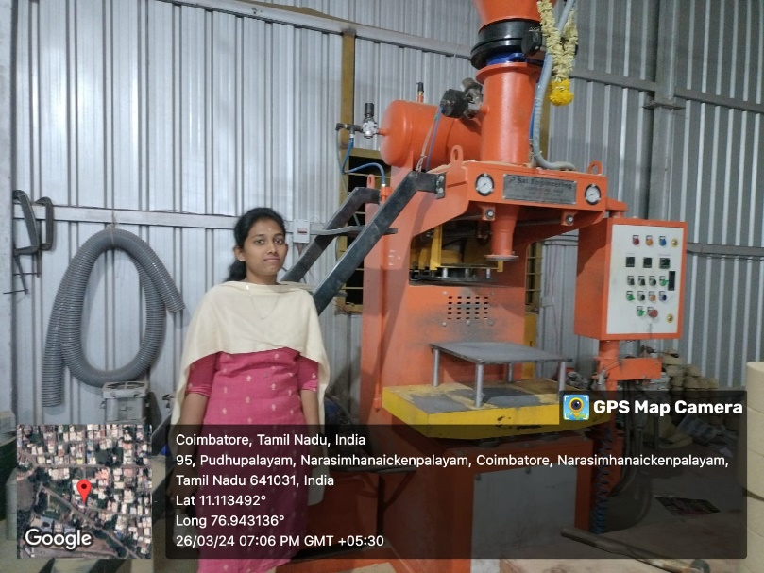

**Molding Machines**

**Interacting With Them**

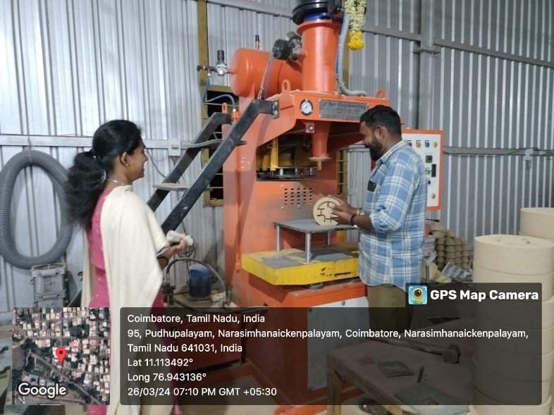

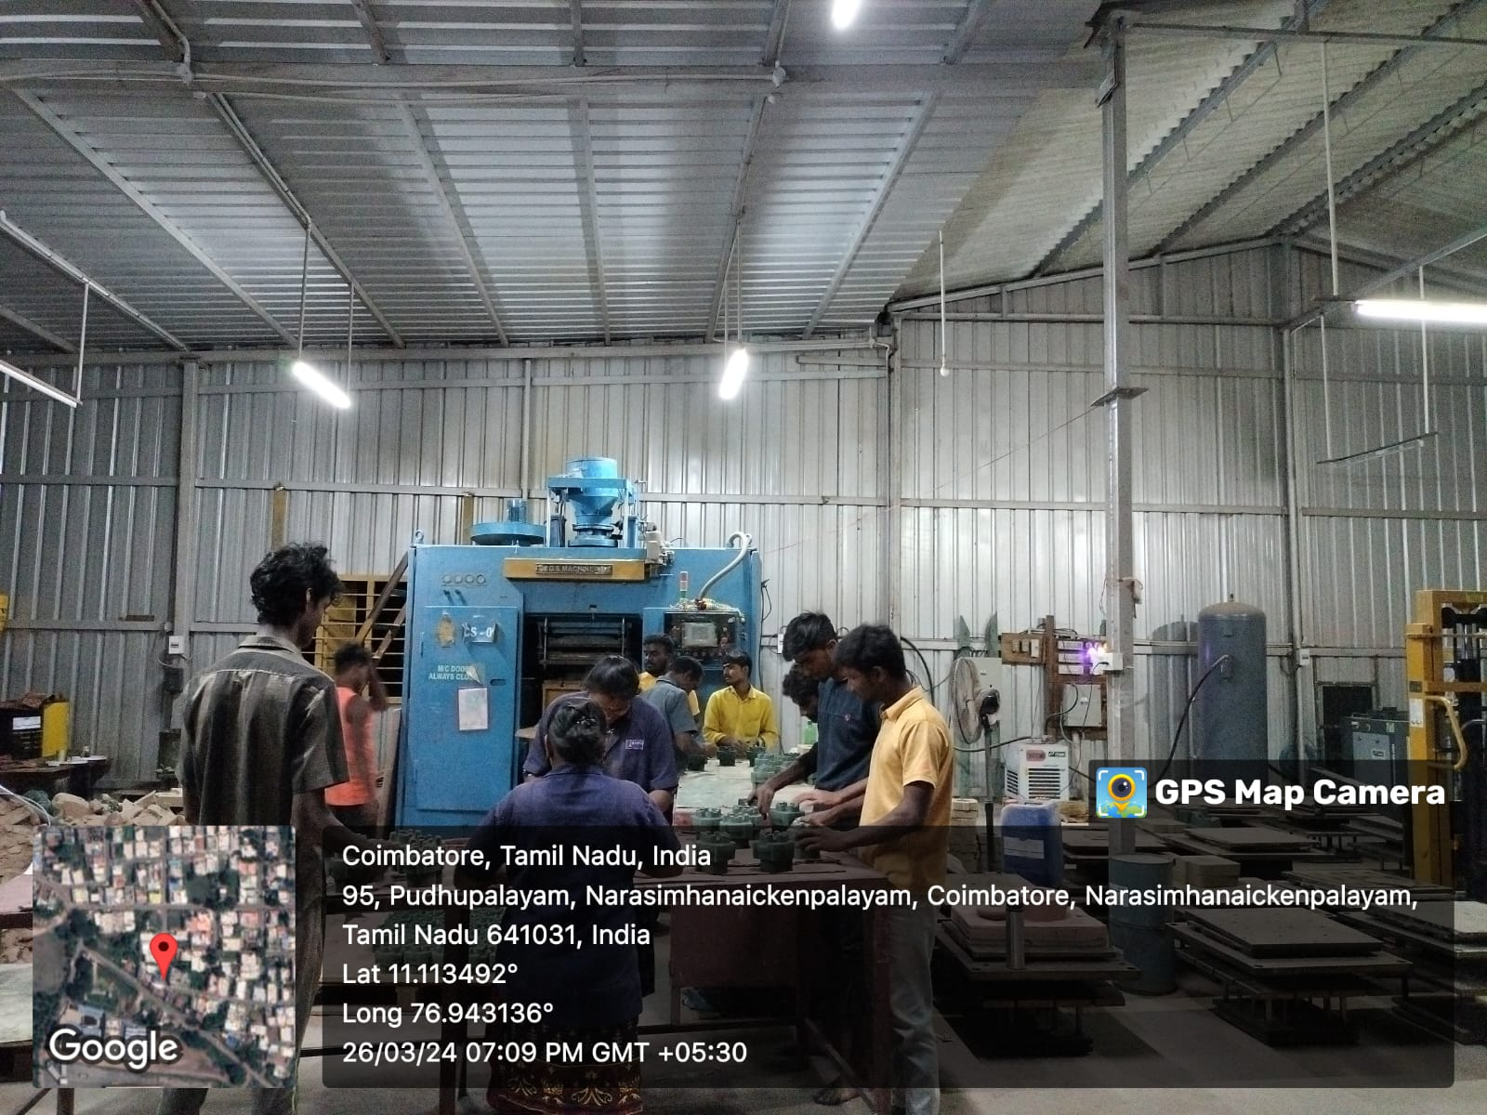

**Working Time**

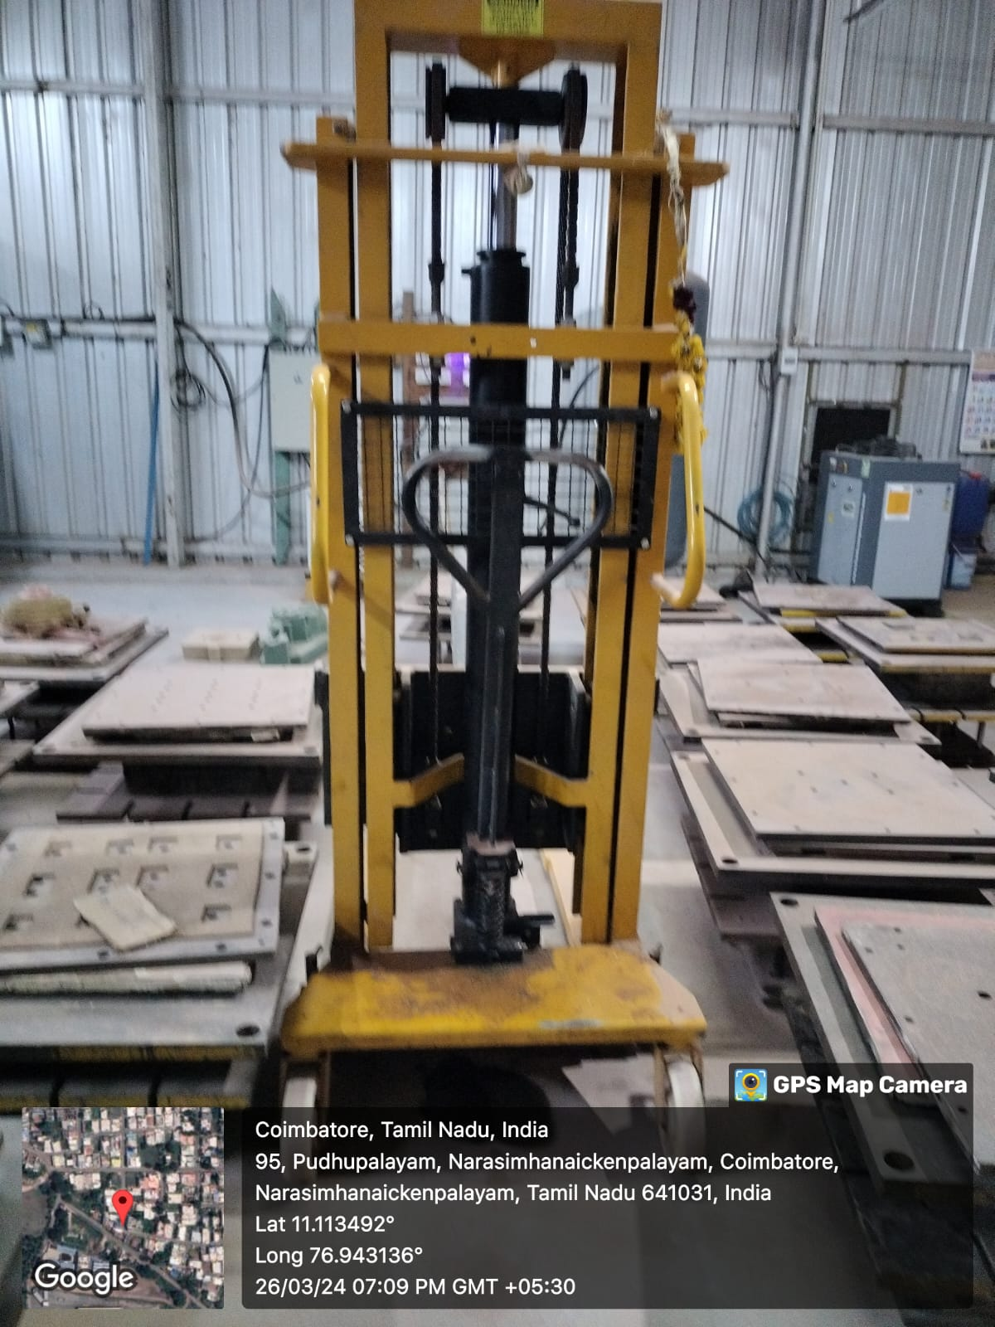

**Machines**